# **Proposal For the project work on FrontEnd and Basic BackEnd Development**

# **Group members:**

# Purna Bahadur Lungeli

# Bishal Kharel

# Shree Krishna Sapkota

# **Title:Pahilo Mart**

# Start date:

# End date:

# Project work type: Group project

# 1.Introduction

Pahilo Mart is an ecommerce platform for selling and buying of goods, products or services over the internet. Basically e-commerce is a commercial transaction method for buying and selling goods which happens all over the internet. It is an emerging concept that describes the process of selling and exchanging via computer. There are different types of e-commerce sites, this type of our project is based on business to customer (B2C) like Alibaba, Amazon etc. Pahilo Mart is a website based on the online retailers where customers can buy different types of products. In our eyes we see it as a new dimension to the varied use of the internet and our purpose is to make it trendy in our country Nepal where its use is increasing day by day. In the context of an online system it is very important to develop trust among the people. Our main aim is to develop an ecommerce website in Nepal that should be accepted by nepalese people largely.

.we

## 1.1 Background Study

Nepal is a developing country so information communication and technology are playing important roles in the development of the country. Simply, ecommerce means buying and selling products over the internet and computer networks. In truth in Nepal, Nepali e-commerce is not being successful to gain trust. Previously we saw the problem of online bills but now these problems are solved by startups like eswa, khalti along with many more. E-commerce is fast growing around Nepal as in the world. We see there are many electronic stores in Nepal but they only think to sell their product so they are failing to gain of customer’s trust. The first thing to gain the trust we must be conscious about the customer’s review. It plays an important role to keep a consistent relationship with customers. Second, nepali sites cannot deliver quality products which do not make good engagement with customers. Thus, we firstly focus on quality of products as well as our time management.

## 1.2 Statement of problem

Our project aims to develop an online shopping site for users with a goal to provide products of customer's choice. With the help of Pahilo Mart users do not need to go outside i.e crowded areas form the home. Pahila mart comes with the facility of simple uses. But there will still be some requirements for users i.e without internet and mobile/computer users can not use services of the Pahilo Mart. Again users have to make an account at first that will be available on the signup page in our website. After successful signup users can login their account then purchase the products and make sure users are connected to the internet.

## 1.3 Objectives

* To provide unique customer experience
* To establish better business relationships
* To improve customer loyalty
* To sell more products
* To reduce management costs
* To boost the efficiency of services

# 2.Methodoly

## 2.1 Requirement Engineering

### 2.1.1 Requirement Collection

By conducting the interview (open ended).

### 2.1.2 Required Categorization on the basis of module/Entity

One of the most important and challenging task is the database design.The information passed by the customer while registering on the website is stored in the database. The program has a lot to do with the database.

We will have four tables in the database namely: Brand, category,product and users. The table entitled “product” has the attributes namely:product_id,product_rate,category_id,brand_id and product_rate.

|  |  |
| --- | --- |
| Category_id | ……………….. |
| Product_id | ………………… |
| Product_rate | ………………… |
| Brand_id | ……………………. |
| Description | ………………………… |
| Price | ………… |

Table:- Product

|  |  |
| --- | --- |
| Name | ……………. |
| Customer_id | ………….. |
| Product_id | ……….. |
| Quantity | ……………… |
| Email | …………….. |

Table:- Customer

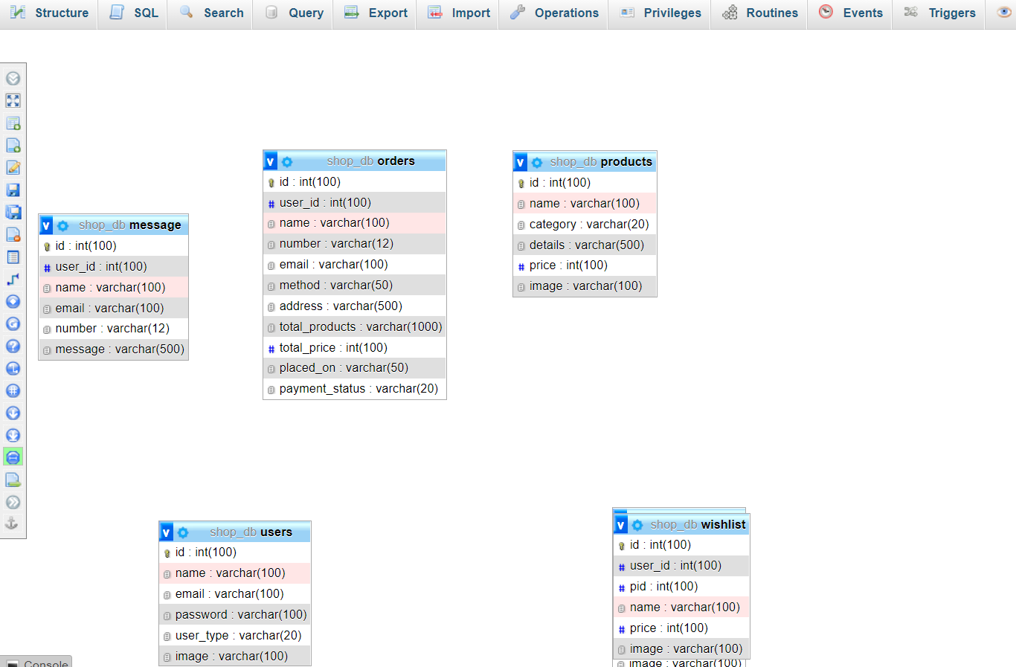

## 2.2 Implementation

### 2.2.1 Tools and Technology

The entire development technology has been divided into two:the front end development and the backend development.The frontend development comprises of visually visible parts such as homepage of site,add to cart page, loginpage, shopping cart page.The backend consists of database part and its interaction with the frontend.

* Front End Development : The frontend was initially coded using Javascript. Javascript is a client side scripting language which is a dedicated language for web development. Javascript code was simply mixed with hyper text markup language (HTML). Html is also known as the skeleton of a webpage which is used for designing web pages.

Designing of web pages was performed using cascading style sheets(CSS).CSS is a stylesheet language used for designing web pages and making web pages user friendly.CSS helps in formatting the text written in markup language.

* Backend Development : For backend development we have used the PHP language. PHP is a server scripting language, and a powerful tool for making dynamic and interactive Web pages.The database management system provides support for the back end. The database management system is a software where we can create the database , add, drop, and update the database. In our project we have chosen the MYSQL DBMS to hold the database.

## 3. Time plan

|  |  |  |  |  |  |  |  |  |  |  |  |  |
| --- | --- | --- | --- | --- | --- | --- | --- | --- | --- | --- | --- | --- |
| Weeks  Activities | 1 | 2 | 3 | 4 | 5 | 6 | 7 | 8 | 9 | 10 | 11 | 12 |
| Requirement analysis |  |  |  |  |  |  |  |  |  |  |  |  |
| System Design |  |  |  |  |  |  |  |  |  |  |  |  |
| Implementation |  |  |  |  |  |  |  |  |  |  |  |  |
| Testing |  |  |  |  |  |  |  |  |  |  |  |  |
| Documentation |  |  |  |  |  |  |  |  |  |  |  |  |

## 4. Reference

* S. E. Ullah, T. Alauddin and H. U. Zaman, "Developing an E-commerce website," 2016 International Conference on Microelectronics, Computing and Communications (MicroCom), 2016, pp. 1-4, doi: 10.1109/MicroCom.2016.7522526.
* DOI “<https://ieeexplore.ieee.org/abstract/document/7522526>”